JAVA SCRIPT COURSE

LECTURE 1
Day 1
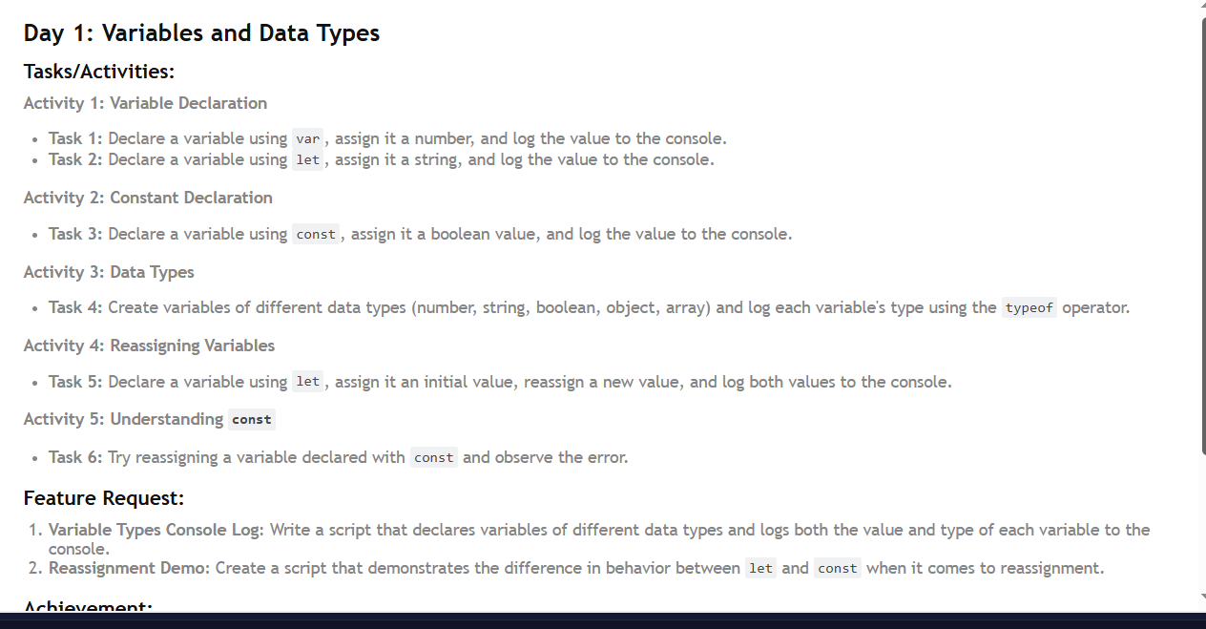
task 1 :
var num=4;
console.log(num);

output:4

task2

let name="tayyab";
console.log(name);

output:tayyab

task 3
const container=true;
console.log(container);

output:true
task 4
let num=20;
let string="ahmed";
let game=true;
let arr=[];
let user={};
console.log("THE TYPE OF NUM :",typeof num);
console.log("THE TYPE OF STRING : ",typeof string);
console.log("THE TYPE OF game : ",typeof game);
console.log("THE TYPE OF ARRAY : ",typeof arr);
console.log("THE TYPE OF USER : ",typeof user);

Output :
THE TYPE OF NUM : number
THE TYPE OF STRING : string
THE TYPE OF game : boolean
THE TYPE OF ARRAY : object
THE TYPE OF USER : object

TASK5
let num=20;
console.log(num);
num=35;
console.log(num);

OUTPUT:
20
35

Day 2

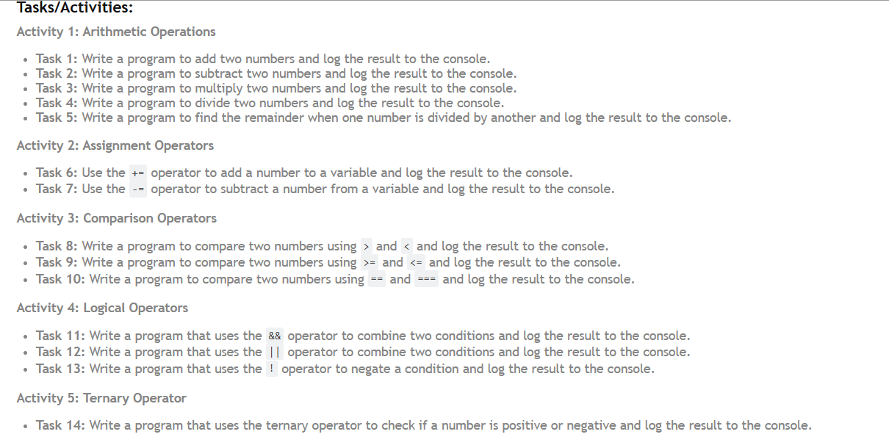

ACTIVITY ONE
ARITHMETIC OPERATORS
let numb1=9;
let numb2=4;
let sub=numb1-numb2;
console.log("THE SUBTRACRTION OF TWO NUMBER : ",sub);

let numbe1=9;
let numbe2=4;
let multi=numbe1*numbe2;
console.log("THE MULTIPLICTION OF TWO NUMBER :",multi);

let number1=9;
let number2=4;
let divi=number1/number2;
console.log("THE DIVISION OF TWO NUMBER :",divi)

let nu1=9;
let nu2=4;
let rem=nu1%nu2;
console.log("THE REMAINDER OF TWO NUMBER :",rem);

OUTPUT
THE ADDITION OF TWO NUMBERS IS : 13
THE SUBTRACRTION OF TWO NUMBER : 5
THE MULTIPLICTION OF TWO NUMBER : 36
THE DIVISION OF TWO NUMBER : 2.25
THE REMAINDER OF TWO NUMBER : 1

ASSIGNMENT OPERATOR

let num1=4;
let num2=9;
num1+=num2;
console.log("THE ADDITION OF TWO NUMBERS IS : ",num1);

let numb1=9;
let numb2=4;
numb1-=numb2;
console.log("THE SUBTRACRTION OF TWO NUMBER : ",numb1);

output
THE ADDITION OF TWO NUMBERS IS : 13
THE SUBTRACRTION OF TWO NUMBER : 5

LESS THAN GREATEH THEN SYMBOLS
GREATER THAN
let num1=4;
let num2=9;
if(num1>num2)
{
console.log("num1 is greater");
}
else
console.log("num2 is greater");

OUTPUT
num2 is greater

LESS THAN

let num1=4;
let num2=9;
if(num1<num2)
{
console.log("num1 is LESSER");
}
else
console.log("num2 is LESSER");

OUTPUT
num1 is LESSER

DOUBLE OR TRIPPLE EQUAL TO
let num1=4;
let num2=4;
if(num1==num2)
{
console.log("THEY ARE EQUAL");
}
else
console.log("NOT EQUAL");
OUTPUT:
THEY ARE EQUAL

TRIPPLE EQUAL(CHECK BOTH MATCHES THE VALYUE AND DATA TYPE ALSO )
let num1=4;
let num2="4";
if(num1===num2)
{
console.log("THEY ARE EQUAL");
}
else
console.log("NOT EQUAL");

OUTPUT
NOT EQUAL(BECAUSE THE VALUE IS SAME BUT DATA TYPE IS NOT SAME NUM1 IS NUMBER NUM2 IS STRING)

TERNARY OPERATOR

let num1=-2;
(num1>0)? console.log("num1 is positive"):console.log("num1 is negative");

OUTPUT
num1 is negative

Day 3

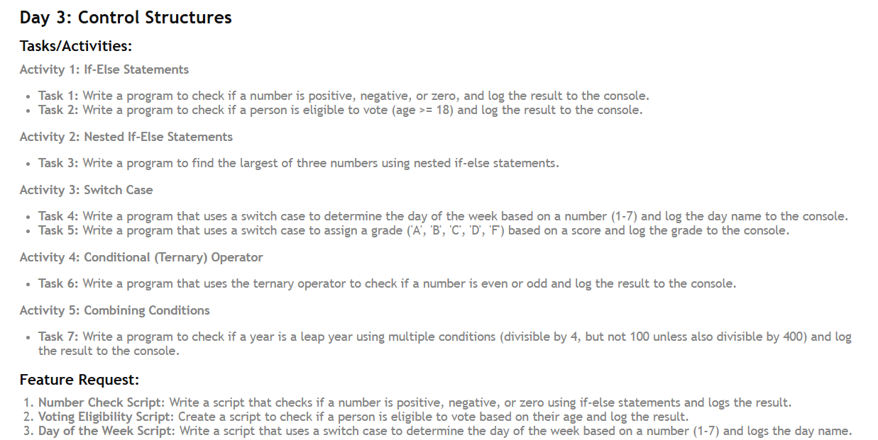

Task 1
let num=prompt("enter the number : ");
if(num<0)
{
console.log("THE NUMNER IS NEGATIVE ");
}
else if(num===0)
{
console.log("THE NUMNER IS ZERO");
}
else if(num>0)
{
console.log("THE NUMNER IS positive ");
}
else
{
console.log("you enter incorrect number ")
}

